SIMATS ENGINEERING
ASSESSMENT TOOL III – Penetration testing Task

Course: | Code: | CO: CO3
Duration: 90 min | Total Marks: 50 | Reg No : 192371013  Name : Keerthika S

COURSE OUTCOME COVERED
CO3: Analyze network services using port scanning, ping sweeps, and enumeration techniques across different operating systems to identify vulnerabilities.( BL4)
Duration: 90 min

Instructions: Answer all questions. Each question carries 10 marks.

An organization has commissioned an external penetration test to determine how much information an unauthorized attacker could gather about its internet-facing infrastructure without directly attacking its systems. Using the theHarvester tool against the authorized domain tesla.com, conduct a comprehensive reconnaissance exercise to identify publicly available email addresses, subdomains, hostnames, IP addresses, URLs, and other relevant infrastructure information. determine how it contributes to the external attack surface, including the risks associated with exposed employee information, unnecessary subdomains, hostnames, and externally hosted services. how multiple pieces of information could be combined by an attacker, the associated risks, recommended controls to reduce information disclosure, and which findings should be validated during subsequent penetration-testing phases. Required Tool: theHarvester.
Objective :
To perform passive reconnaissance on the authorized domain tesla.com using theHarvester and identify publicly available hosts, subdomains, IP addresses, email addresses, and other infrastructure information.
Tool Used
- Tool: theHarvester
- Version: 4.8.2
- Target: tesla.com
- Type: Passive Reconnaissance / OSINT

Commands Used :
- bash
- theHarvester -h
- theHarvester -d tesla.com -b duckduckgo -l 100
- theHarvester -d tesla.com -b bing -l 100
- theHarvester -d tesla.com -b crtsh -l 100
- theHarvester -d tesla.com -b duckduckgo,bing,crtsh -l 200
- theHarvester -d tesla.com -b duckduckgo,bing,crtsh -l 200 -f tesla_recon

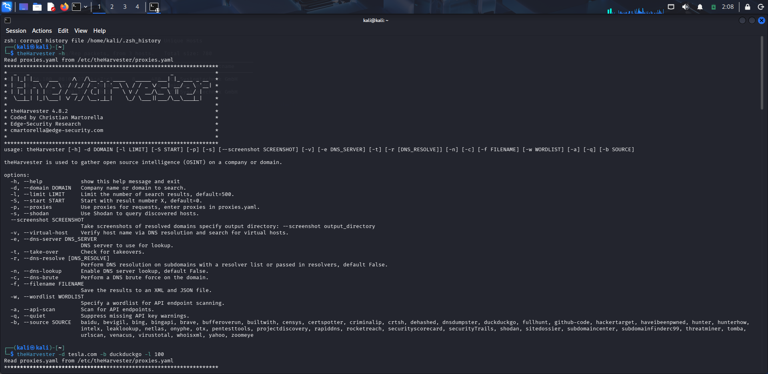

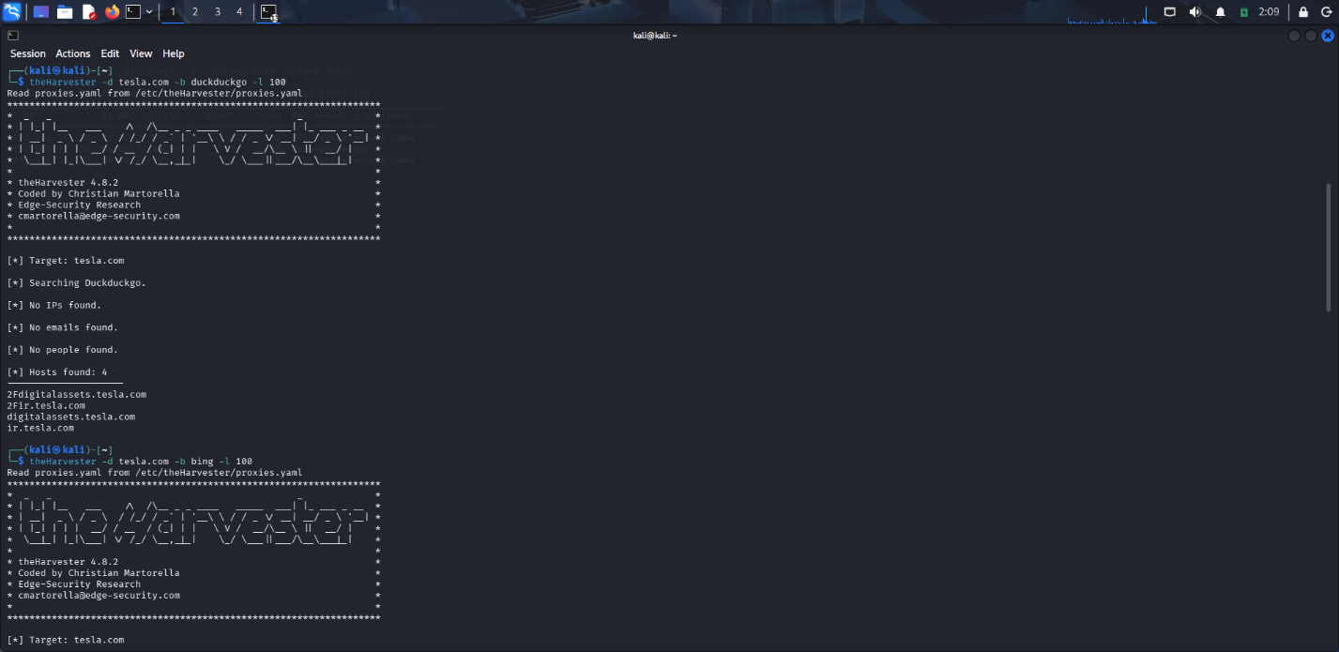

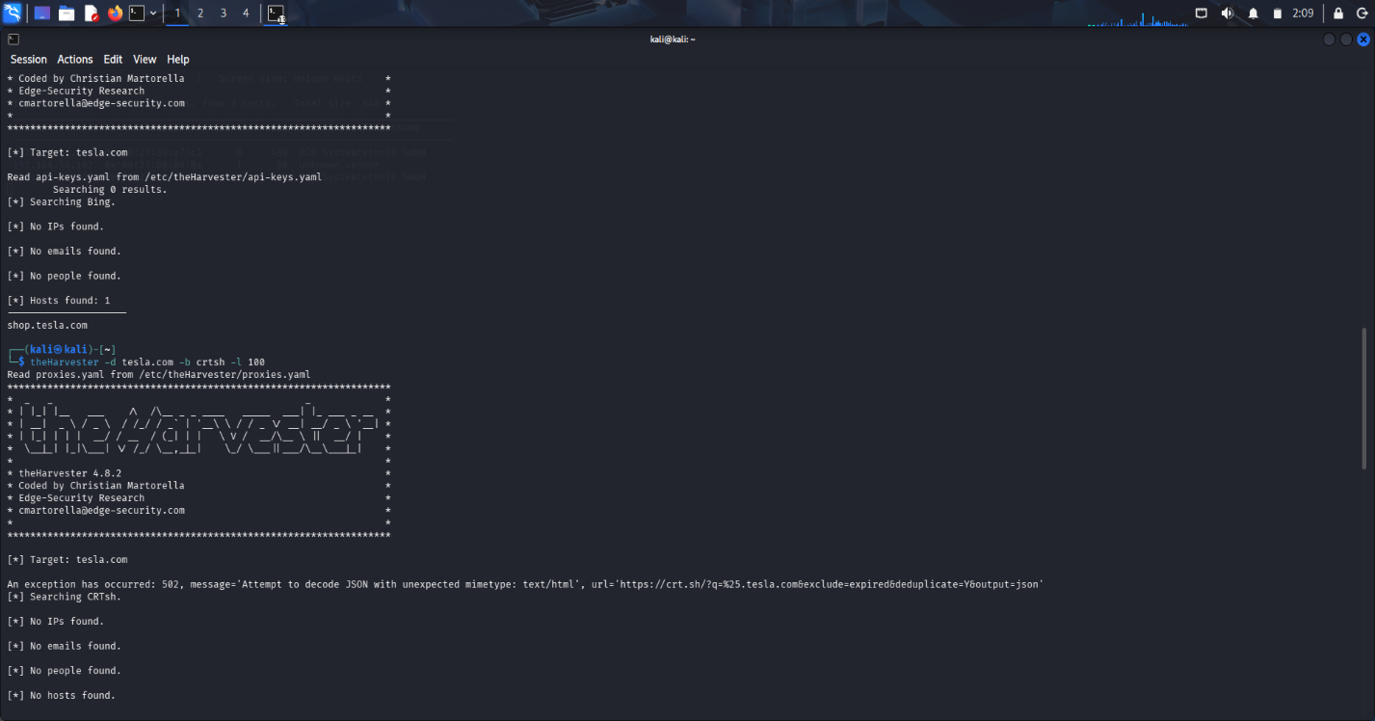

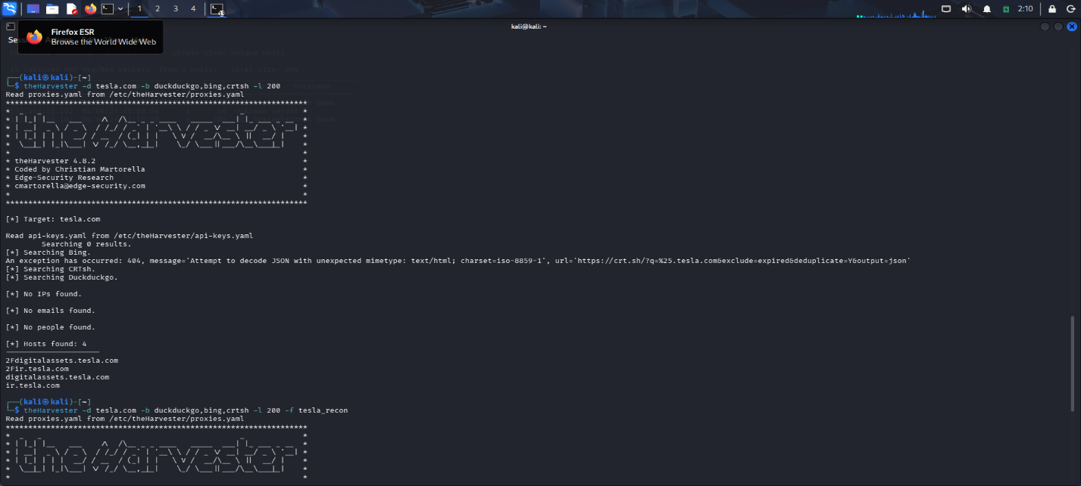

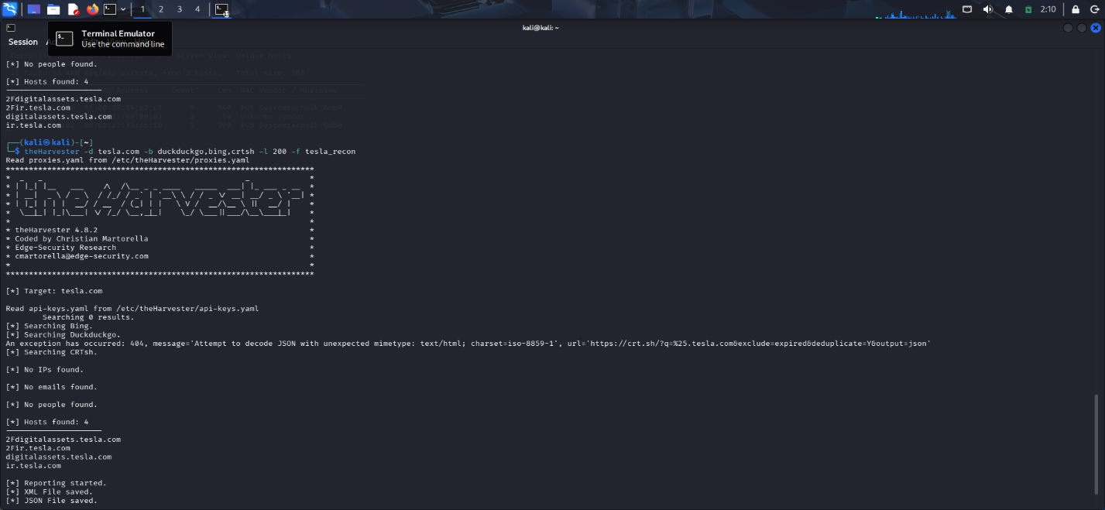

Results
- DuckDuckGo: 4 hosts discovered.
- Bing: 1 host discovered.
- IP addresses: None found.
- Email addresses: None found.
- People: None found.
- CRTsh: No hosts returned because the source produced HTTP errors.
- Output: XML and JSON reports were successfully generated.

Hosts Discovered
- 2Fdigitalassets.tesla.com
- 2Fir.tesla.com
- digitalassets.tesla.com
- ir.tesla.com
- shop.tesla.com
The hosts were obtained from the DuckDuckGo and Bing searches.
Security Analysis

Risk and Recommendations
Unused or unnecessary subdomains should be removed. Organizations should maintain an external asset inventory, regularly review publicly exposed hosts, minimize unnecessary information disclosure, and validate externally accessible services during later penetration-testing phases.

Conclusion
TheHarvester successfully performed passive reconnaissance against tesla.com and identified 5 hostnames from the available search results. Although no emails or IP addresses were found, the discovered hosts contribute to the external attack-surface information available to an attacker. The CRTsh source could not be used successfully because of HTTP errors. The final scan successfully saved XML and JSON results.
2. During a penetration-testing engagement, assess the publicly accessible web application testphp.vulnweb.com using the Nikto tool to identify potentially exposed files and directories, insecure HTTP methods, server configuration weaknesses, information-disclosure issues, outdated components, dangerous files, and other potential security weaknesses. For every significant finding, collect appropriate evidence and determine whether it represents a confirmed vulnerability, a configuration weakness, or an issue requiring further manual validation. Prepare a final assessment including the commands used, significant findings, supporting evidence, potential security impact, likelihood of exploitation, recommended remediation measures, methods for validating remediation, and a prioritized list of the most important findings, with particular attention to exposed files, server-version information, directory listings, insecure HTTP methods, and outdated components. Required Tool: Nikto.
Objective:
To assess an authorized vulnerable web server using Nikto and identify outdated software, information disclosure, missing security headers, and configuration weaknesses.
Target: 192.168.56.102 - Metasploitable 2 Tool: Nikto 2.5.0
Protocol: HTTP/80
Procedure :
- First, connectivity was verified : ping -c 4 192.168.56.102
- The web service was checked : curl -I http://192.168.56.102
- The server returned : HTTP/1.1 200 OK
- Server: Apache/2.2.8 (Ubuntu) DAV/2
- X-Powered-By: PHP/5.2.4-2ubuntu5.10
- The security scan was performed using : nikto -h http://192.168.56.102
Results : Nikto identified
- Outdated Apache 2.2.8.
- Outdated PHP 5.2.4.
- Server/PHP version disclosure.
- Missing X-Frame-Options.
- Missing X-Content-Type-Options.
- Apache MultiViews enabled.
- Uncommon tcn header requiring validation.
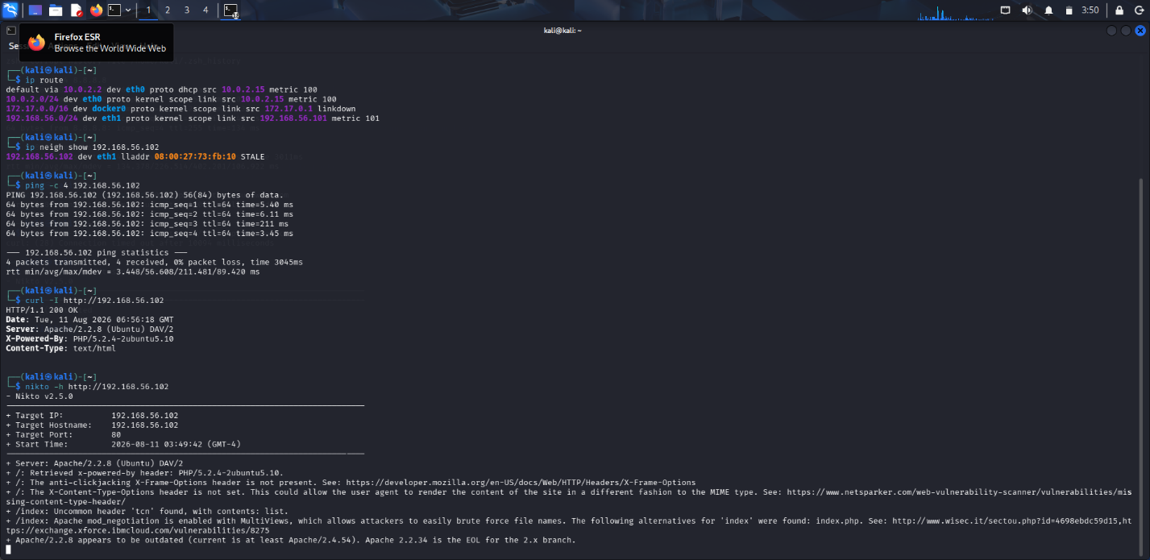
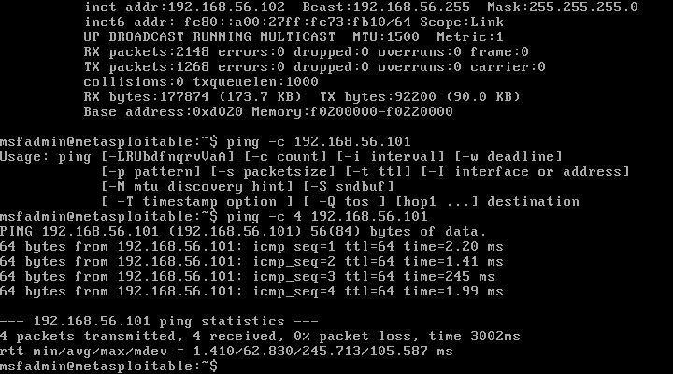
Risk Analysis:
The outdated Apache and PHP versions represent the highest-priority risks because obsolete components may contain known vulnerabilities. The remaining findings are primarily configuration and information-disclosure weaknesses.
Conclusion:
The Nikto assessment was successfully completed against the authorized Metasploitable 2 server and demonstrated how Nikto can identify outdated components and web-server configuration weaknesses.

- A company is conducting an external security assessment to determine whether its DNS infrastructure discloses more information than intended. Using the Dig utility against the authorized target domain zonetransfer.me, perform a detailed DNS enumeration exercise by identifying and documenting the available A, AAAA, MX, NS, CNAME, TXT, SOA, and other relevant DNS records, determining the authoritative servers, and assessing whether an unauthorized DNS zone transfer can be requested. Analyze the results from an attacker’s perspective and explain how DNS records can reveal mail infrastructure, server naming conventions, hostnames, service relationships, and other infrastructure information. Your assessment should identify the DNS records and authoritative servers, determine whether a zone transfer was possible, explain the additional information exposed by a successful zone transfer and the risks of unrestricted AXFR access, discuss how DNS information can be combined with other reconnaissance techniques, recommend appropriate DNS security controls, and explain how remediation can be verified. Required Tool: Dig.
Objective
To enumerate DNS records of the authorized domain zonetransfer.me, identify its authoritative DNS servers and test whether an unauthorized DNS zone transfer is possible using Dig.
Tool Used
Tool : Dig Target : zonetransfer.me
Platform : Kali Linux
Commands Used :
- bash
- dig zonetransfer.me
- dig zonetransfer.me NS
- dig zonetransfer.me SOA
- dig zonetransfer.me A
- dig zonetransfer.me AAAA
- dig zonetransfer.me MX
- dig zonetransfer.me CNAME
- dig zonetransfer.me TXT
- dig AXFR zonetransfer.me @nsztm1.digi.ninja
- dig AXFR zonetransfer.me @nsztm2.digi.ninja
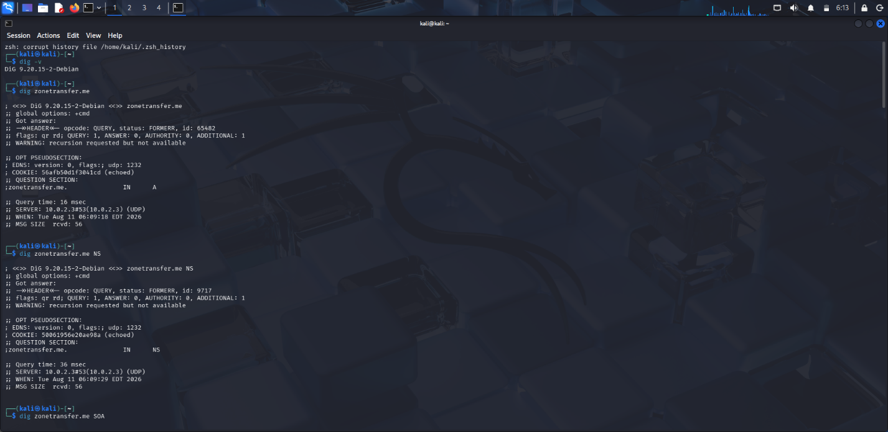
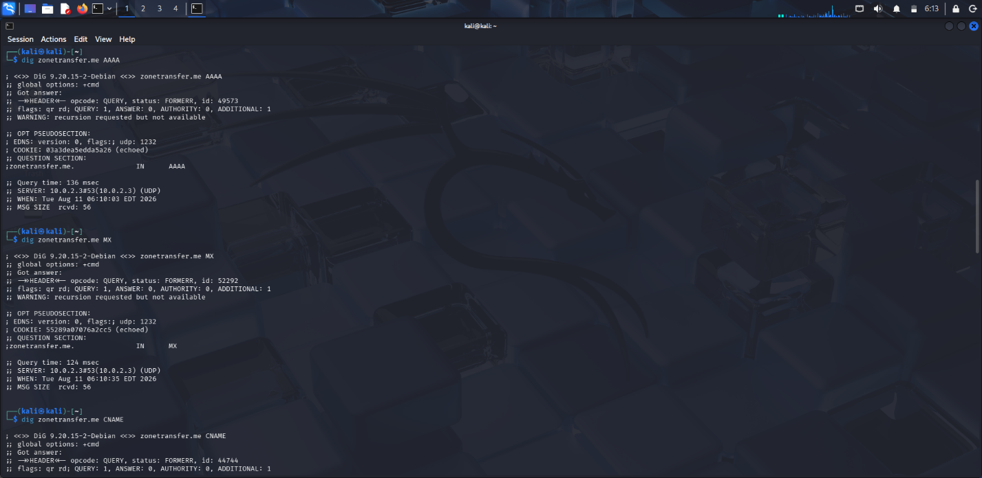
Observation
The initial normal DNS queries returned FORMERR because the configured DNS server 10.0.2.3 did not provide the expected recursive response. Direct AXFR queries to the authoritative servers were successful.
Information Exposed
- The successful transfer revealed:
- Web server IP addresses
- Google mail infrastructure
- VPN hostname and IP
- Office-related hosts
- Service and protocol information
- Additional DNS metadata
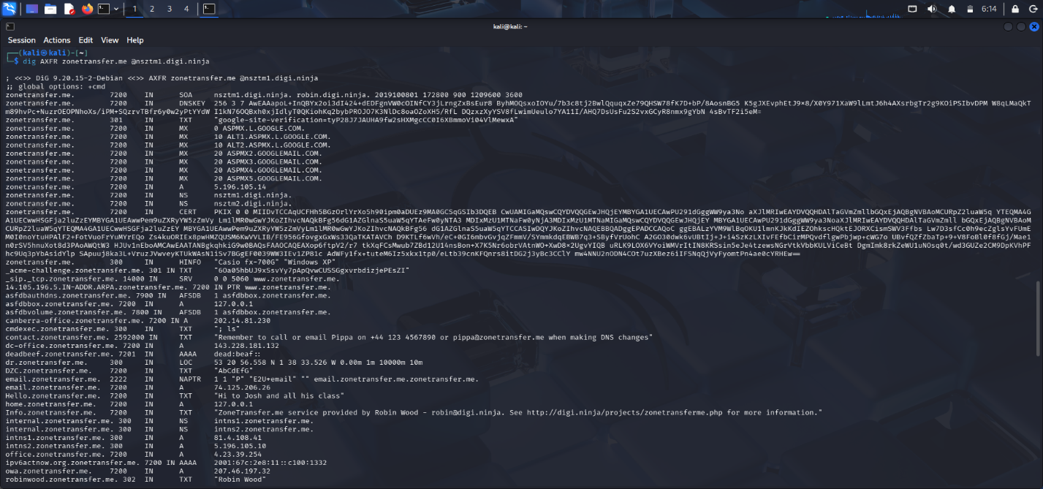
Results
The experiment was successfully completed. AXFR was possible against both authoritative DNS servers, and 52 records were obtained from each server. The results demonstrate the information-disclosure risk of unrestricted DNS zone transfers.
Security Impact
An unrestricted AXFR allows an attacker to obtain a large portion of the DNS zone without discovering each hostname individually. This can simplify reconnaissance and help identify systems for further security testing.
Mitigation
- Restrict AXFR to trusted secondary DNS servers.
- Use authenticated DNS transfers such as TSIG.
- Separate internal DNS from public DNS.
- Remove unnecessary DNS records.
- Monitor DNS transfer requests.
Conclusion
Dig successfully performed DNS enumeration and zone-transfer testing against the authorized training domain. The assessment demonstrated how DNS records can expose infrastructure information and how unrestricted AXFR can increase an attacker's reconnaissance capability.

- As part of an internal penetration-testing engagement, assess the authorized Windows/SMB target 192.168.1.100 using Enum4linux to determine what information could be obtained through SMB and NetBIOS enumeration before attempting exploitation. Perform comprehensive enumeration to identify available users, groups, shared resources, domain or workgroup information, operating-system details, password-policy information, NetBIOS information, and other exposed SMB configuration details permitted by the target. Analyze the collected information from an attacker’s perspective and determine whether it could facilitate credential attacks, privilege escalation, unauthorized access to shared resources, vulnerability identification, or lateral movement. Prepare a report containing the commands used, identified users and groups, discovered shared resources, relevant system and domain information, evidence of anonymous or null-session enumeration, security implications, relationships between accounts, groups and privileges, risks of unnecessarily accessible SMB shares, recommended controls, and a prioritized remediation plan covering SMB configuration, access control, authentication, patching, and network segmentation. Required Tool: Enum4linux.
Objective :
To enumerate an authorized Windows SMB system and identify exposed users, groups, shares, NetBIOS information, workgroup details, and password-policy weaknesses.
Target and Tools
Target : 192.168.56.102
Tester : Kali Linux
Required tool : Enum4linux v0.9.1
Supporting tools : Nmap, smbclient
Network : Isolated VirtualBox Host-Only network
Procedure :
- First, SMB connectivity was verified using : nmap -Pn -p 139,445 192.168.56.102
- The result showed:
- 139/tcp → open
- 445/tcp → open

- Enum4linux was then executed : enum4linux -a 192.168.56.102
- The scan identified the WORKGROUP workgroup and JAHNAVI NetBIOS name.
- Anonymous enumeration was tested, but the target rejected an empty username/password session.
- Authenticated SMB enumeration using : smbclient -L //192.168.56.102 -U
- ADMIN$
- C$
- IPC$
- Important Findings :
  - Users
- Administrator
- DefaultAccount
- Guest
- WDAG
- UtilityAccount
  - Privileged account:
→ Administrators
  - Password policy:
  - Minimum password length : 0
  - Password history : None
  - Maximum password age : 42 days
  - Lockout threshold : 10
  - Lockout duration : 10 minutes
Security Risks
- SMB is accessible through ports 139 and 445.
- NetBIOS/workgroup information is exposed.
- Local account information can assist username reconnaissance.
- Administrative membership makes the associated account a high-value credential target.
- ADMIN$ and C$ are sensitive administrative shares.
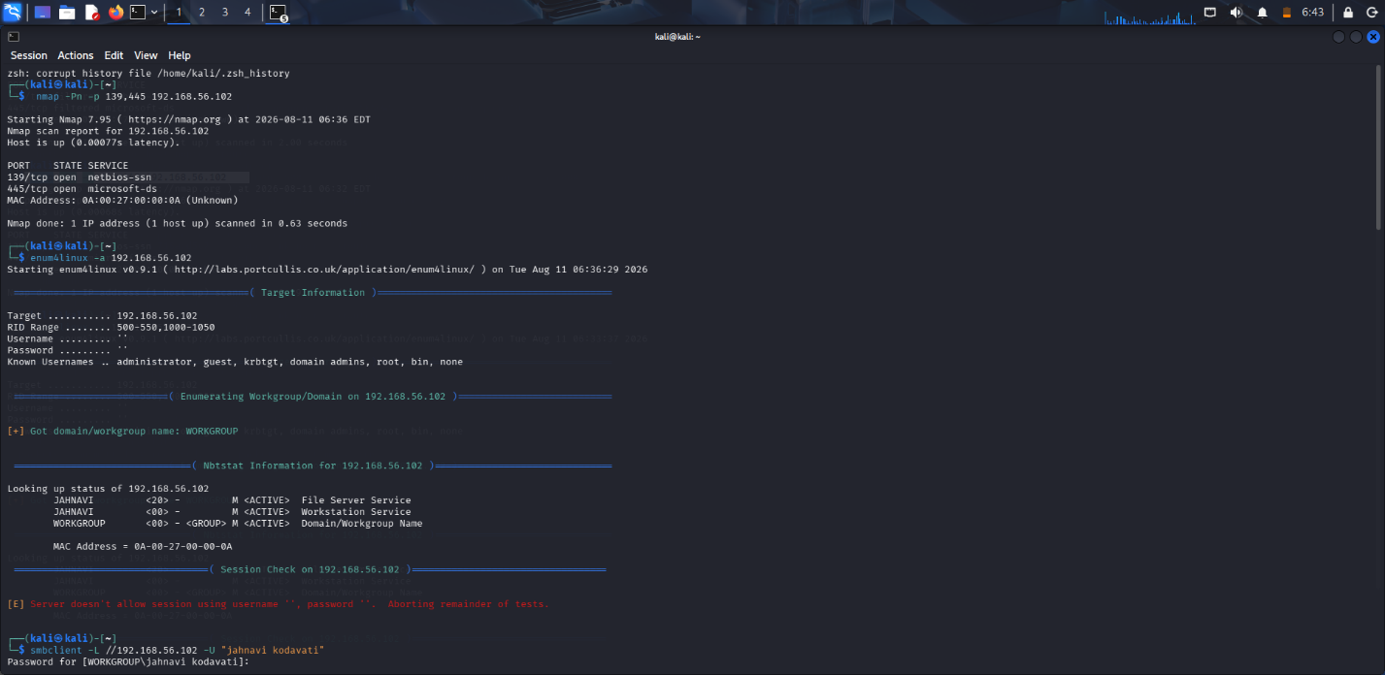

Recommendations
- Restrict SMB access to trusted systems.
- Disable unnecessary SMB/NetBIOS exposure.
- Disable SMB1/legacy SMB functionality.
- Review ADMIN$ and C$ access.
- Apply least privilege to local administrators.
- Enforce strong password length and history requirements.
- Keep Windows patched.
- Segment SMB traffic using network/firewall controls.
Conclusion
The experiment was successfully completed. Enum4linux successfully identified workgroup and NetBIOS information and demonstrated that unauthenticated SMB enumeration was blocked. Authenticated SMB enumeration identified the standard administrative shares, while Windows-side enumeration provided account, group, privilege, and password-policy information. The findings provide useful information for assessing credential-attack, privilege, and unauthorized SMB-access risks.
- During an external penetration-testing engagement, assess the authorized target scanme.nmap.org using Netcat (nc) to connect to accessible TCP services and collect service responses and banner information. Analyze the responses to determine what technical information the target voluntarily discloses, including service type, protocol, software name, version information, HTTP response headers, operating-system clues, and other implementation details. For each significant observation, explain what information was disclosed, which service provided it, how it could assist an attacker with fingerprinting, whether version information could be correlated with known vulnerabilities, whether the finding represents a vulnerability or merely information disclosure, what additional validation is required, and what remediation measures could reduce unnecessary exposure. Finally, explain how the organization should monitor and periodically reassess externally exposed services and discuss the security implications of service-banner exposure and how accurate service fingerprinting can make subsequent attacks more targeted. Required Tool: Netcat (nc).
Netcat External Service Assessment
Objective :
To assess the authorized target scanme.nmap.org using Netcat and identify accessible TCP services, banners, software versions, and security-relevant information disclosure.
Domain: scanme.nmap.org
IP: 45.33.32.156
Tool: Netcat (nc)
Platform: Kali Linux
Commands Used
- ping -c 4 scanme.nmap.org
- nc -vz scanme.nmap.org 22
- nc -v 45.33.32.156 22
- nc -vz scanme.nmap.org 80
- nc -v 45.33.32.156 80
- nc -vz scanme.nmap.org 53
- nc -vz scanme.nmap.org 9929
- nc -v 45.33.32.156 9929

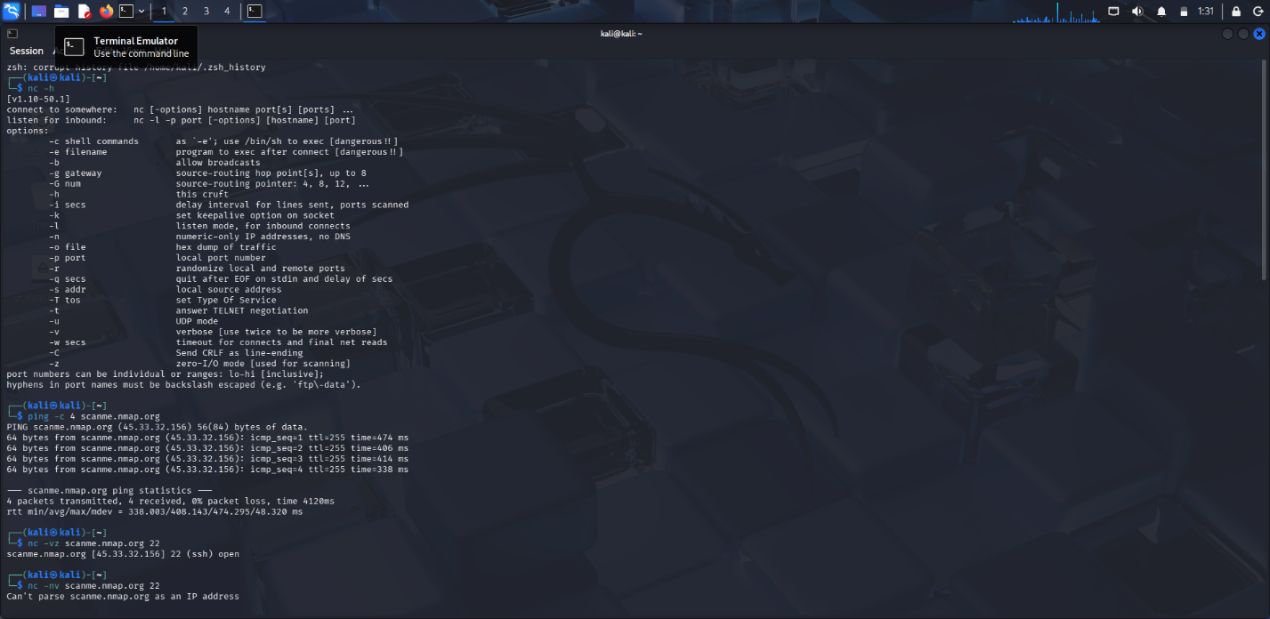
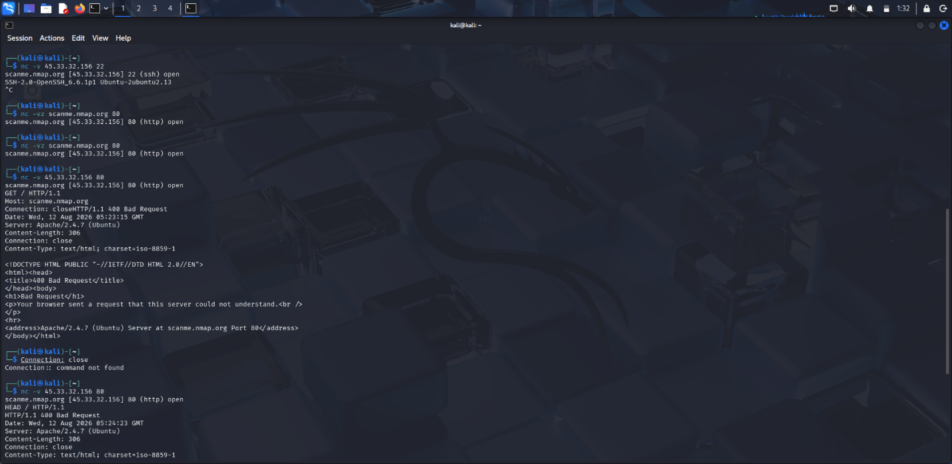
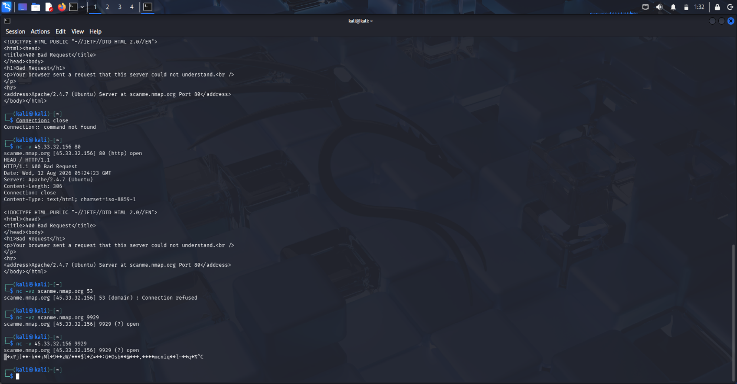

Observations
- Target IP: 45.33.32.156
- Ping: 4/4 received, 0% packet loss
- 22/TCP: Open - SSH
- SSH banner: OpenSSH_6.6.1p1 Ubuntu-2ubuntu2.13
- 80/TCP: Open - HTTP
- HTTP banner: Apache/2.4.7 (Ubuntu)
- 53/TCP: Connection refused
- 9929/TCP: Open - binary response, service not identified
Remediation
- Patch exposed services.
- Restrict unnecessary ports.
- Limit SSH access.
- Reduce unnecessary banner/version disclosure.
- Periodically monitor and reassess Internet-facing services.
Conclusion
The Netcat assessment successfully identified the accessible TCP services and collected SSH and HTTP banner information. The results demonstrate how service banners can assist targeted attacker reconnaissance.

Code of Conduct:
I Gurram Roshitha 192373027 certify that this submission is my original work and that I have adhered to the guidelines specified for this assessment. I understand that any violation of academic integrity rules will result in disciplinary action.
Signature of the student: Gurram Roshitha

RUBRICS FOR CALCULATION:

Criteria | Weightage | Level 4 – Exemplary | Level 3 – Proficient | Level 2 – Developing | Level 1 – Beginning
Understanding of Task | 20
Procedure & Execution | 25
Observation & Result | 20
Viva Voce / Conceptual Response | 20
Time Management & Presentation | 15

Criteria | Understanding of Task | Procedure & Execution | Observation & Result | Viva Voce / Conceptual Response | Time Management & Presentation
Weightage | 20  (2) | 25  (3) | 20  (2) | 20  (2) | 15  (1)
Q1
Q2
Q3
Q4
Q5

